16.Write a program to print Right Triangle Star Pattern
Sample Input:: n = 5
- 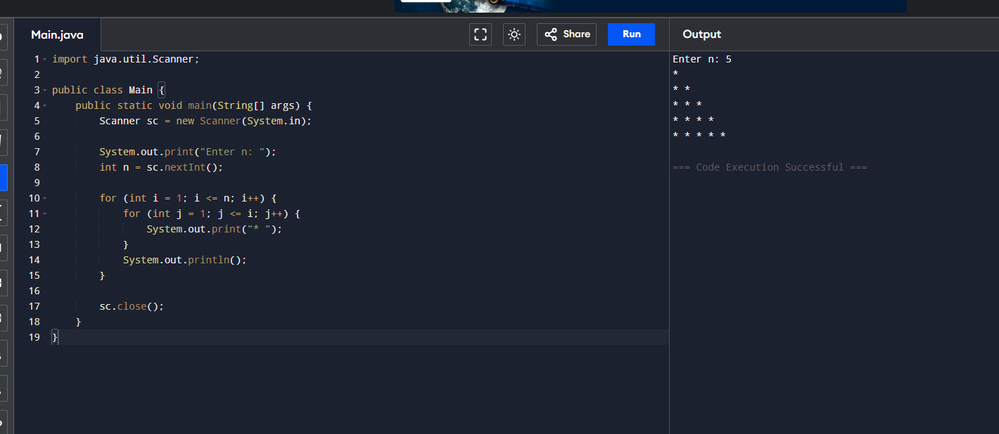17.Write a program to print the below pattern?
 |  |  |  | 1
 |  |  | 1 |  | 1
 |  | 1 |  | 2 |  | 1
 | 1 |  | 3 |  | 3 |  | 1
1 |  | 4 |  | 6 |  | 4 |  | 1
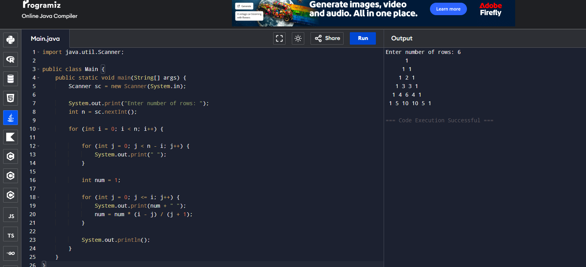
- Write a program to print rectangle symbol pattern.
Get the symbol as input from user

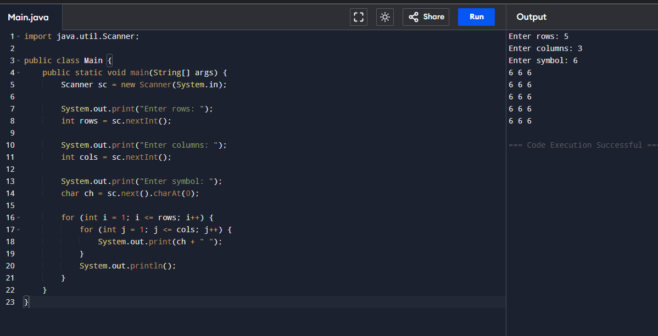
- Write a program to print the following pattern
Sample Input:
Enter the number to be printed: 1
Max Number of time printed: 3
1
11
111
11
1
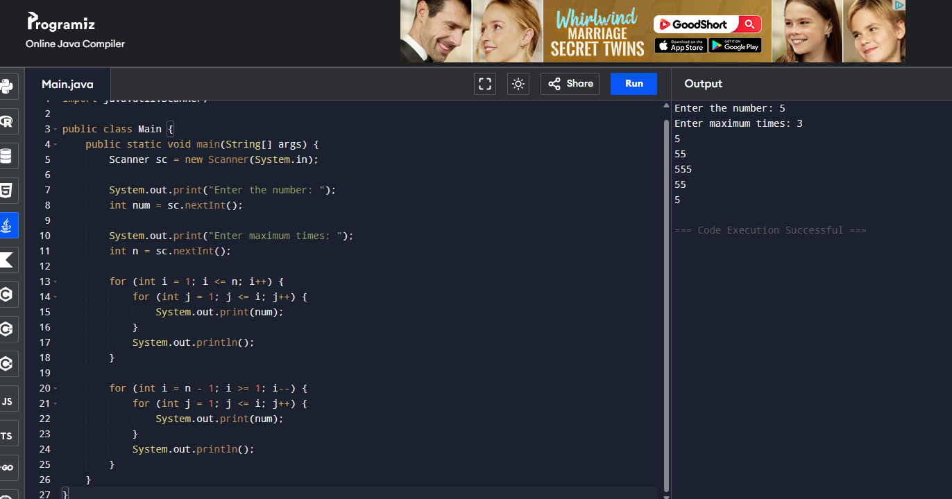
- Write a program to print the Inverted Full Pyramid pattern?
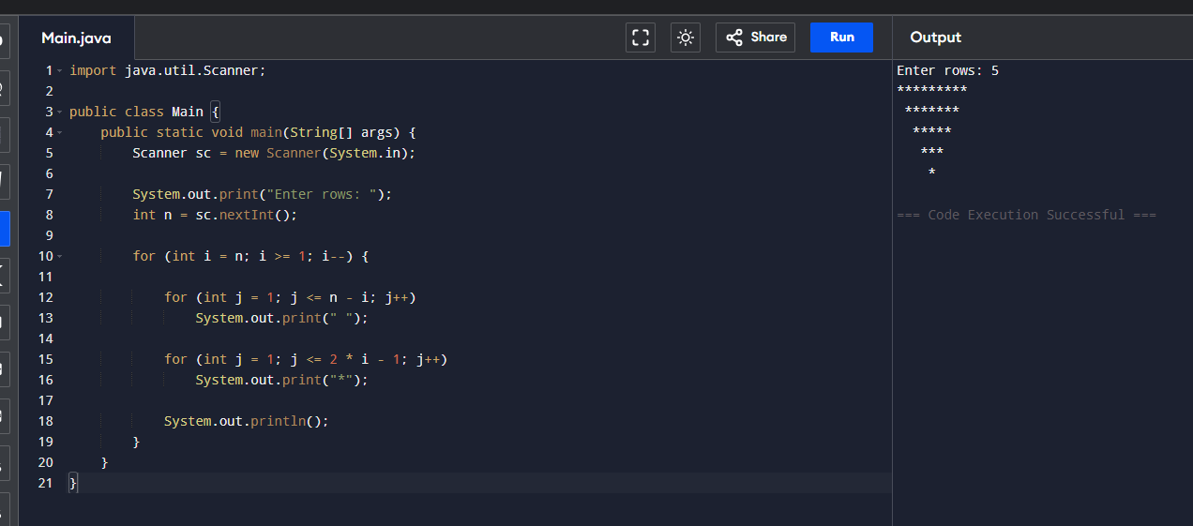
- Write a program to print the following pattern
Sample Input:
Enter the Character to be printed: %
Max Number of time printed: 3
%
% %
% % %

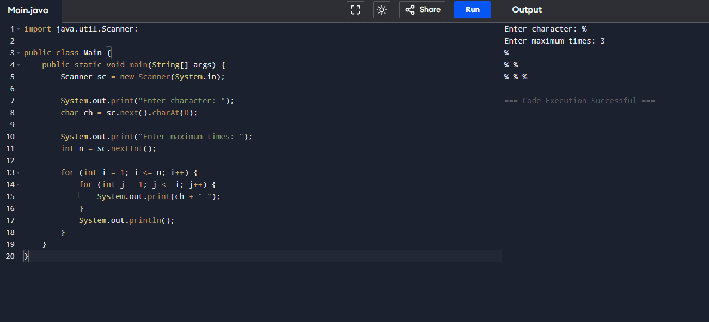
- Write a program to print hollow square symbol pattern?
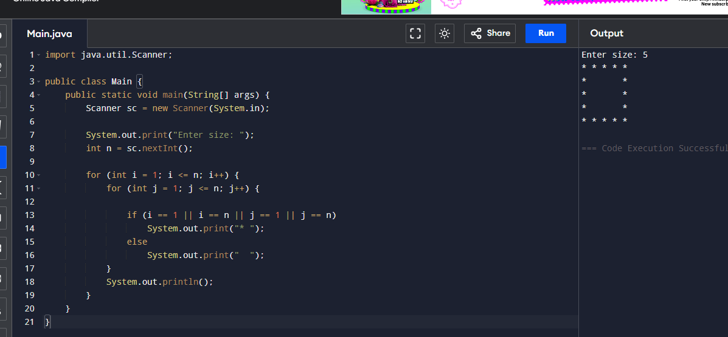
- Write a program to print the below pattern
1
2 2
3 3 3
4 4 4 4

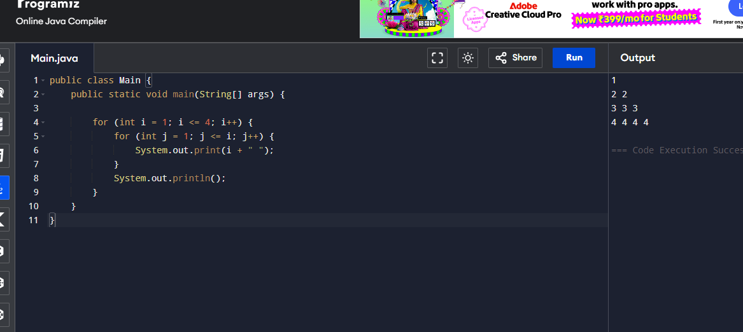
- Write a program to print the below pattern
1
4 9
16 25 36
49 64 81 100
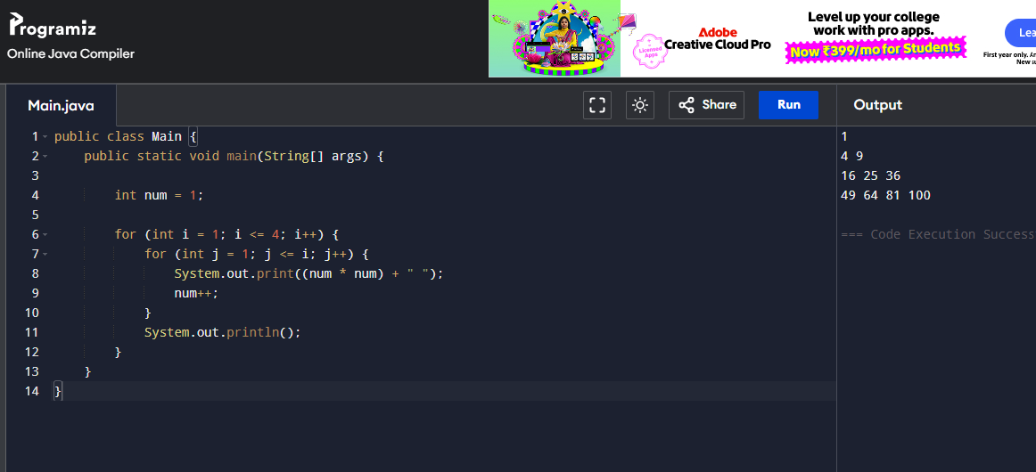
- Write a program to print the below pattern
1
2 2
3 3 3
4 4 4 4
3 3 3
2 2
1

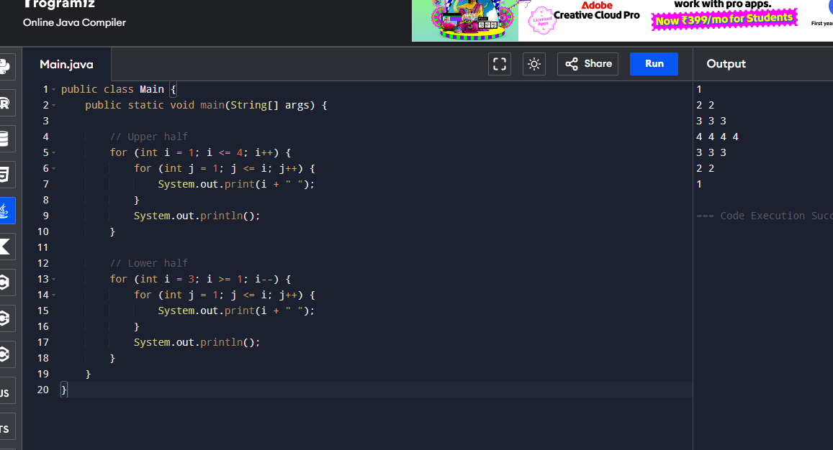
- Write a program to print hollow Square Dollar pattern?
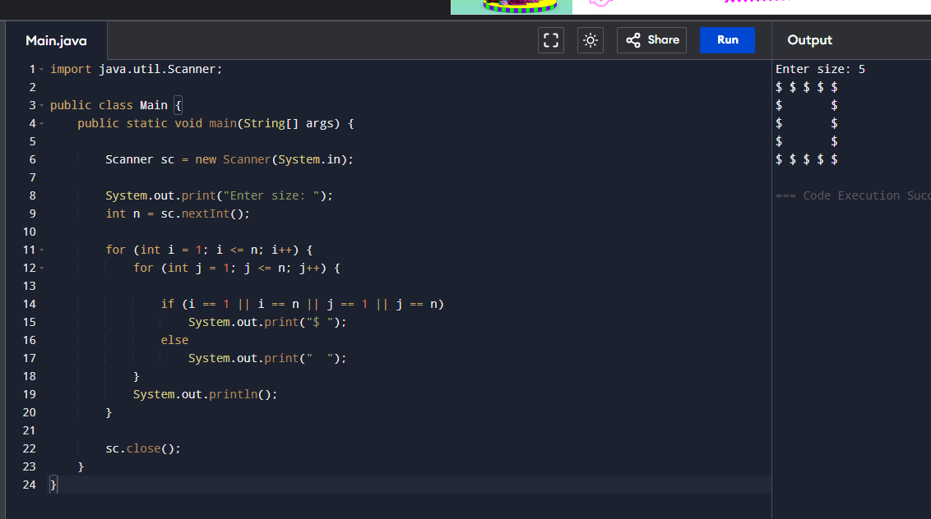
- Write a program to print inverted pyramid pattern.
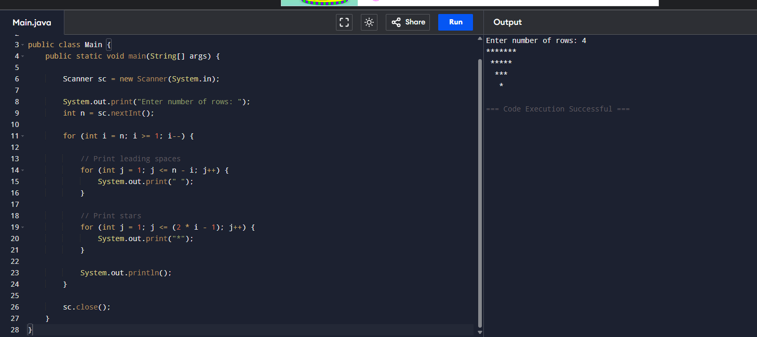
36. Print All Composite Numbers Between A and B
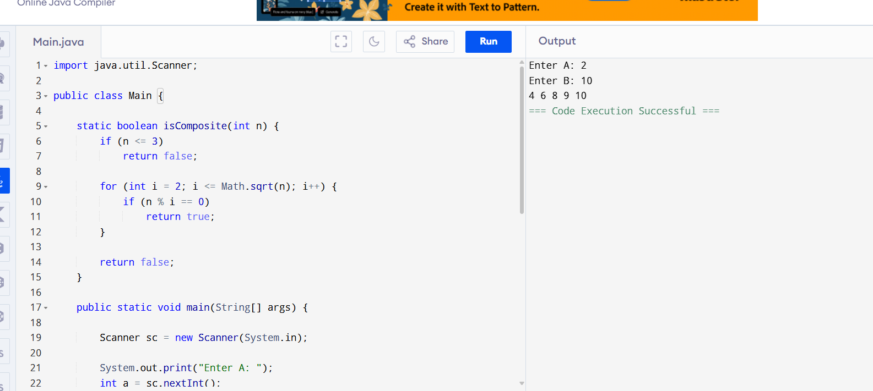
37. Factorial of N
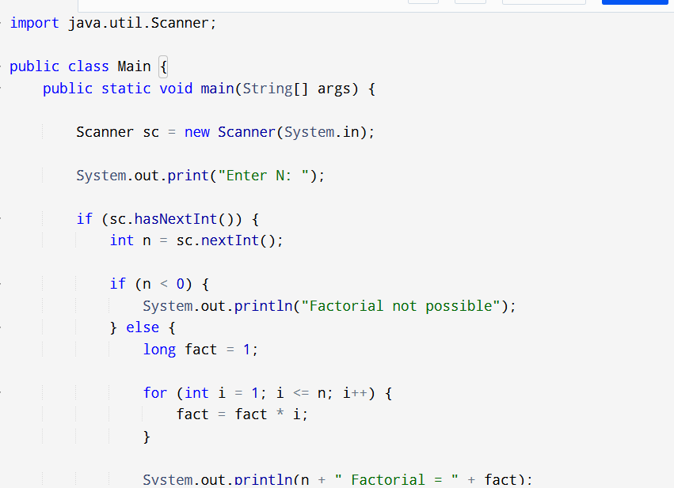
38. Leap Year
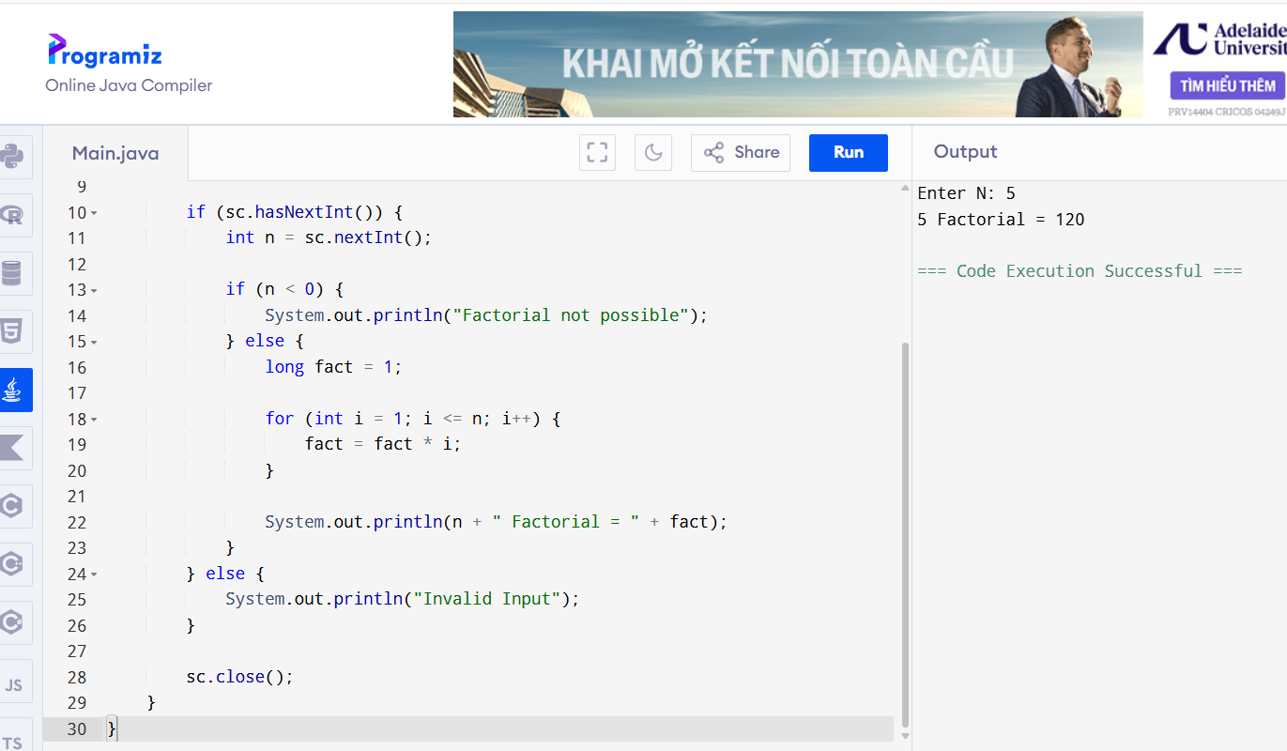
39. Number of Factors
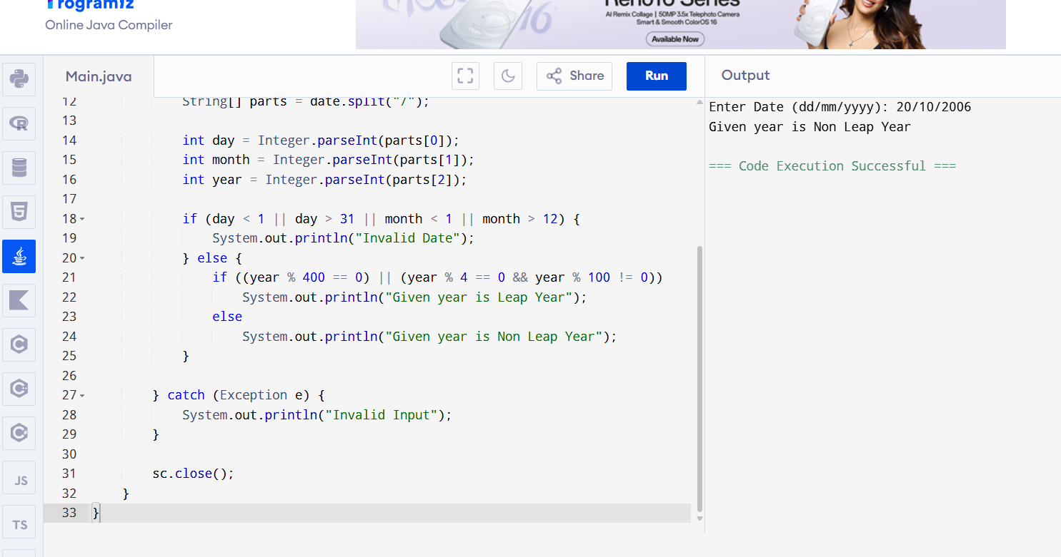
40. Perfect Number
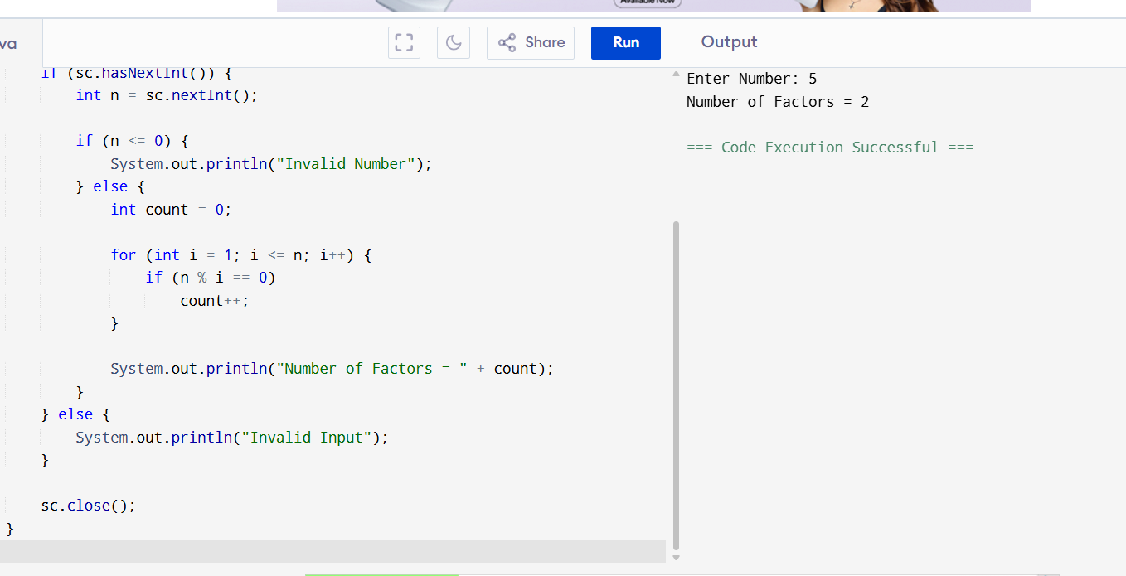
41. Square and Cube of a Decimal Number
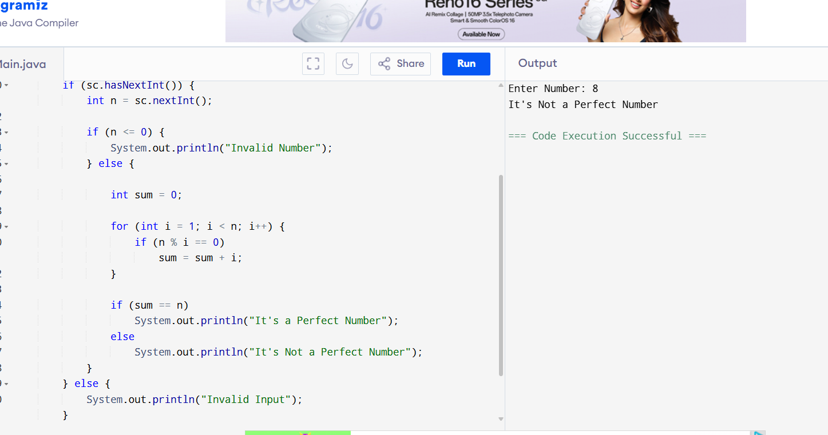
42. Print First N Odd Numbers
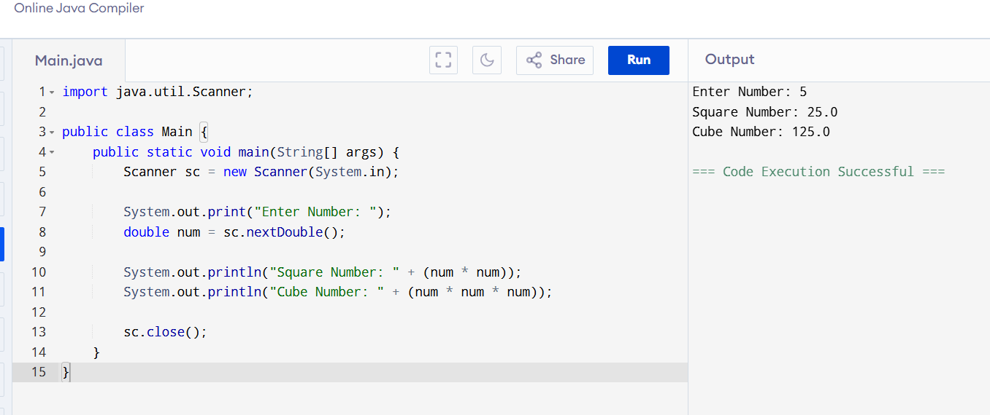
43. Armstrong Number
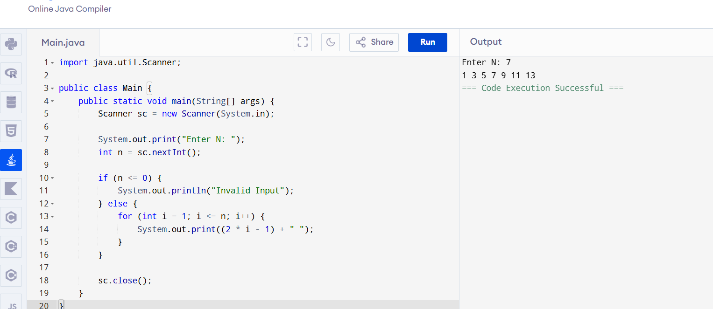
44. Sum of Digits Until Single Digit
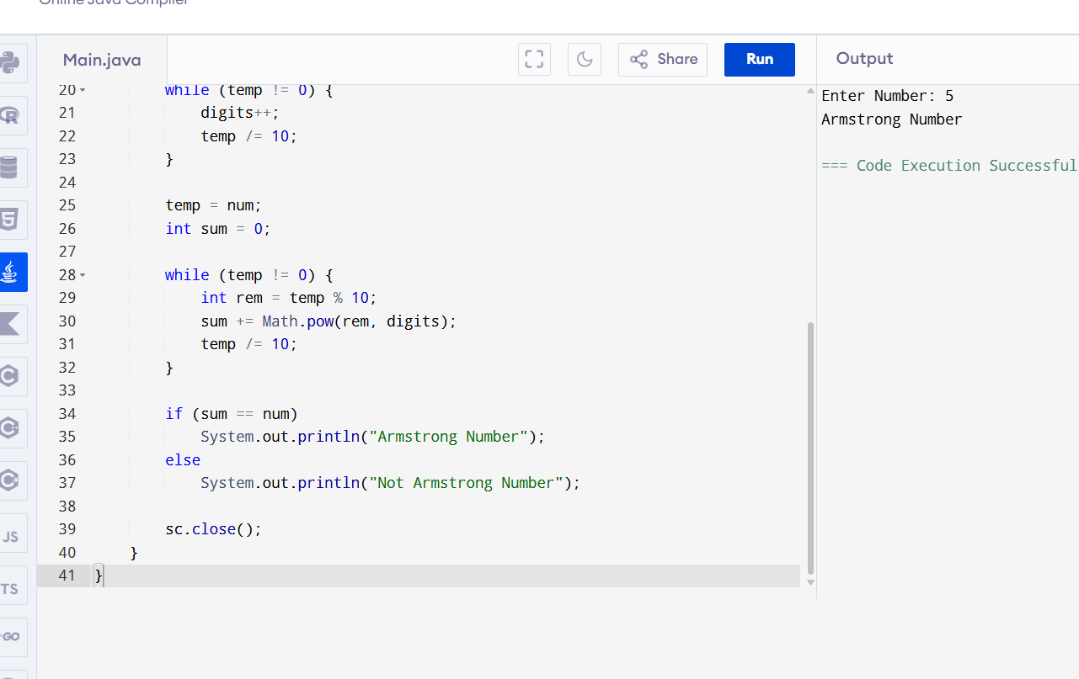
45. Square Root of a Perfect Square
